ESP32 Subcribe to NodeRed Message
Node red setup in browser
- Install Node Red (skip this if u already done install)
  - Install node js
  - Run command prompt and install Node Red
  - Run Node Red local server (do not close during using node-red)
  - Install palette dashboard @flowfuse/node-red-dashboard

- Open Node Red on browser
- Setup nodes as shown below

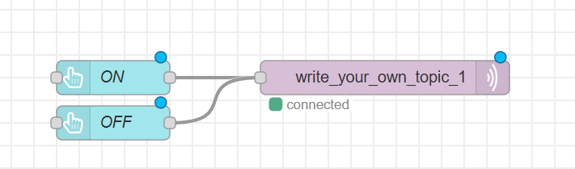

- Setup MQTT OUT nodes

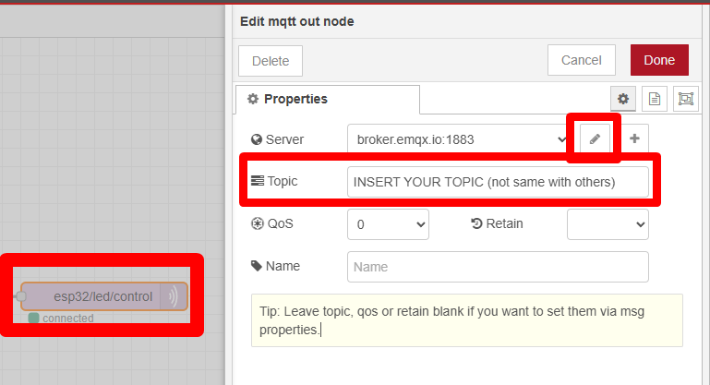

- Set the publish topic name (make sure set same when set the codes in Arduino IDE)
- This topic must match exactly with the subscribe topic defined in the ESP32 program later.
- Topic must be unique, case sensitive and not same with others
- Example topic name pw4/mqtt
- Click pencil to set the Broker Server
- Set Broker to broker.emqx.io

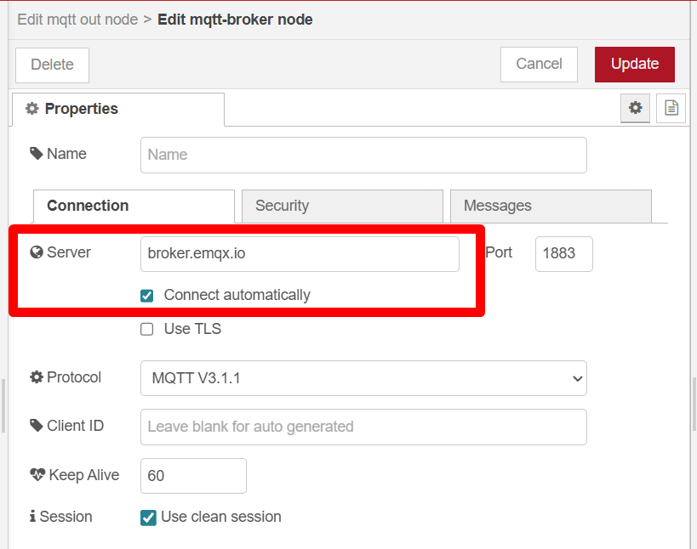

- Setup button ON
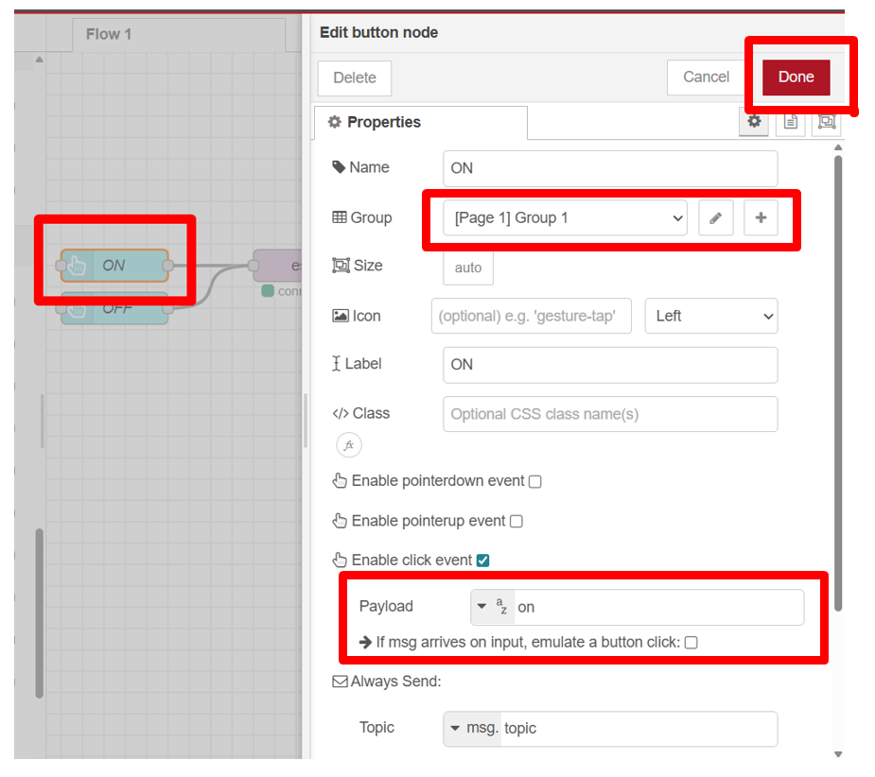

- Setup button OFF

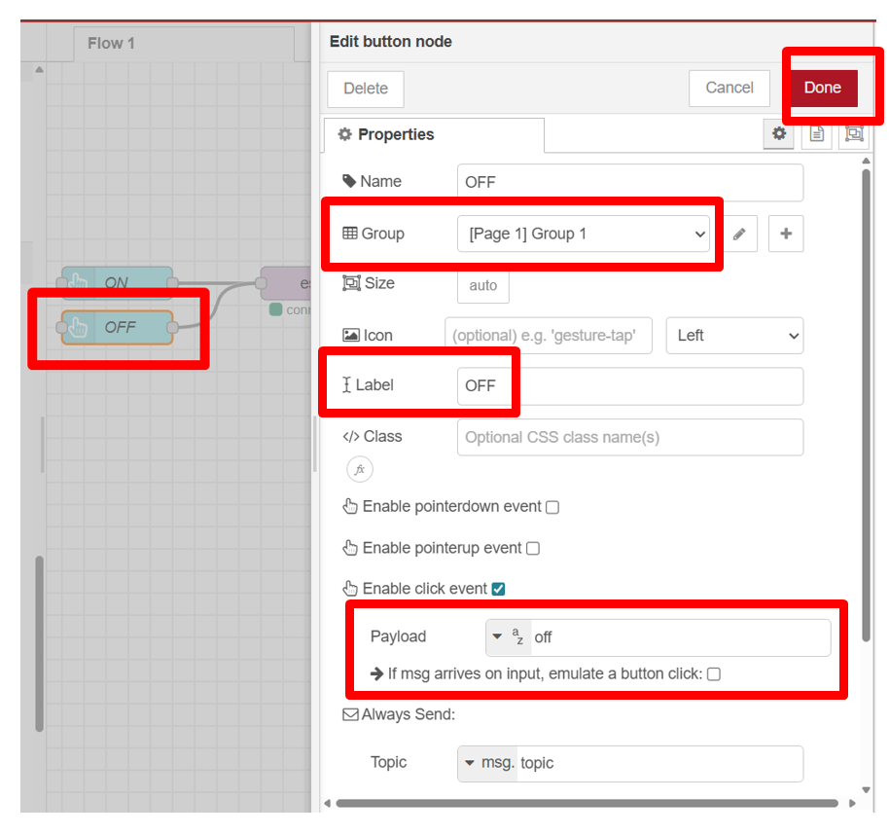

- Complete the setting
- Connect the nodes
- Deploy the nodes

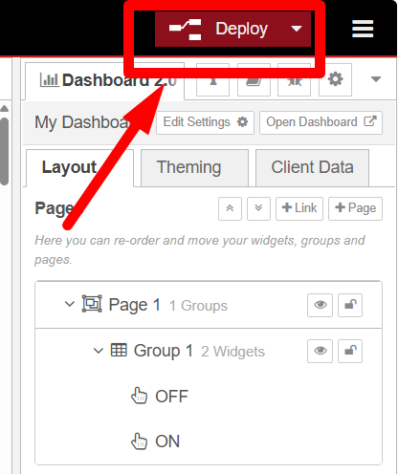

- After deploy, check nodes is “green” connected. This show all setup is correct.
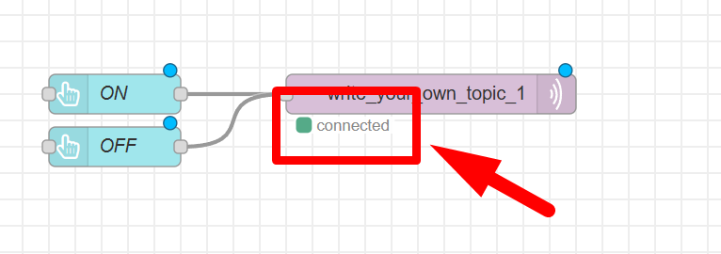

- Open deploy dashboard, by clicking “open dashboard”
- A new window / tab in browser will be open

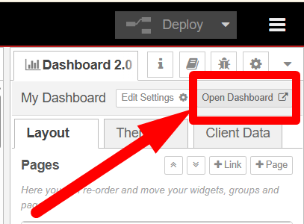

- The deployed dashboard in browser, is shown below.

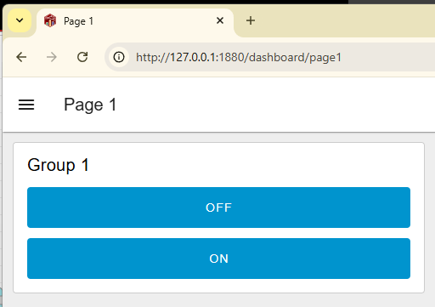

Library setup in Arduino IDE
- Connect the Hardware
- Connect the ESP32 to your computer using a USB cable.
- Make sure the onboard LED of the ESP32 (GPIO 2) is used as an output indicator.
- Open the Arduino IDE.
- Select the board DO IT ESP32 DEVKIT.
- Select the correct COM port.
- Make sure the following library has been installed:
- PubSubClient.h – Download it using the link below.
https://github.com/knolleary/pubsubclient
- How to download the library
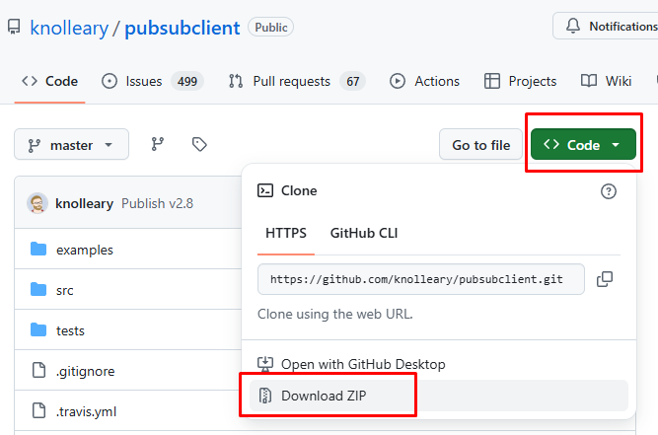
- Update Arduino IDE using the downloaded library file, follow step below
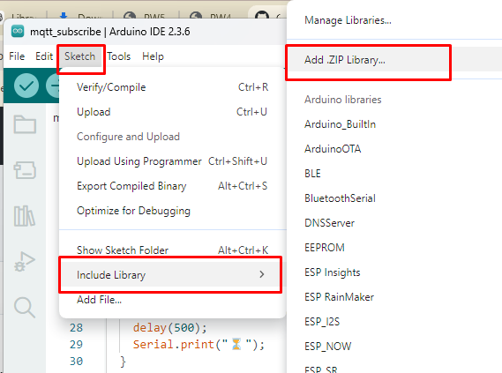
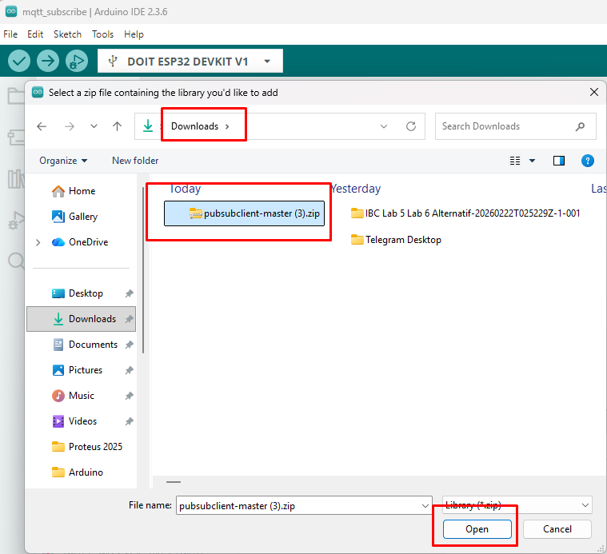
- You will get notification “library installed”
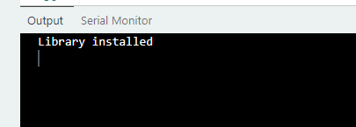

- Upload coding
- Copy code from this link : https://github.com/zulkeflipolimas/DEC30252-Student/blob/main/MQTT%20PreLab/mqtt_subscribe.ino

- Modify the blank spot with suitable credential
  - Wifi SSID
  - Wifi Password
  - Broker Server (refer Node Red broker server link in MQTT OUT Nodes)
  - Subscribe Topic (refer Node Red topic in MQTT OUT Nodes)

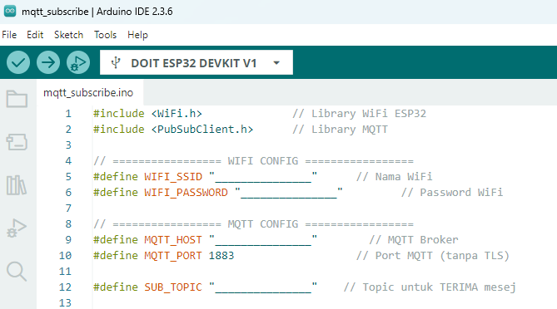

- Upload the code to the ESP32 board. Wait for the upload to finish.
- Open the Serial Monitor in Arduino IDE.
- Set baud rate to 115200.
- Observe the ESP32 connecting to WiFi and the connecting to MQTT server
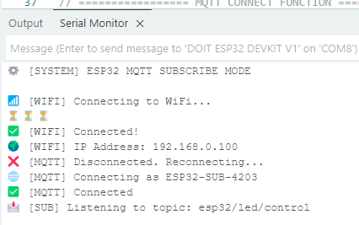

Receiving and Processing MQTT message
- Test the ON button on Node Red deployed dashboard
- Observe the ESP32 LED, the LED should turn ON
- Observe the Serial Monitor:
  - The received topic and message should be displayed.
  - The LED status should be indicated as ON.

- Test the ON button on Node Red deployed dashboard
- Observe the ESP32 LED, the LED should turn OFF.
- Observe the Serial Monitor:
  - The received topic and message should be displayed.
  - The LED status should be indicated as OFF.

Publish LED Status to Node Red
Node red setup in browser

- Modify the nodes for Task 1 in Node Red
- Add the following nodes
- Add MQTT IN, debug and text

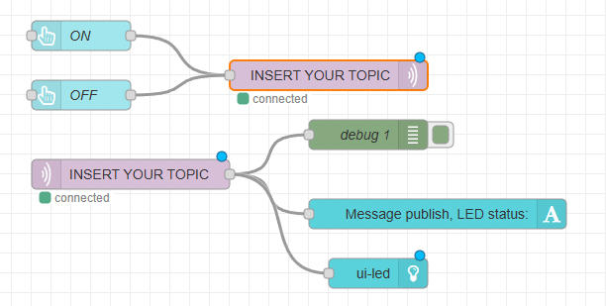

THE TOPIC MUST DIFFER / MUST NOT SAME BETWEEN MQTT OUT AND MQTT IN

- Setup MQTT IN
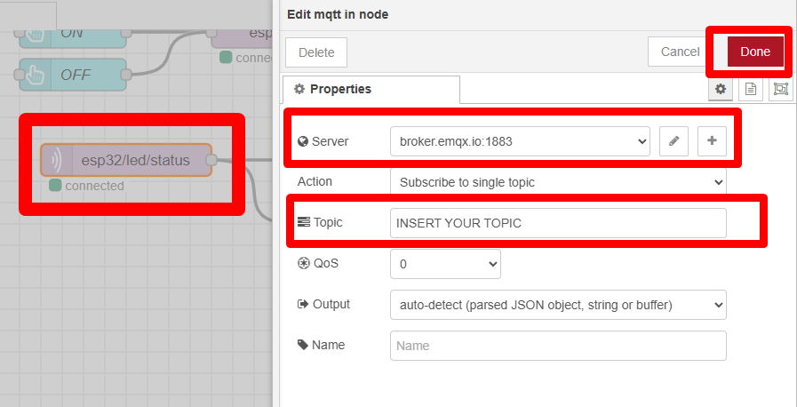

- Setup TEXT
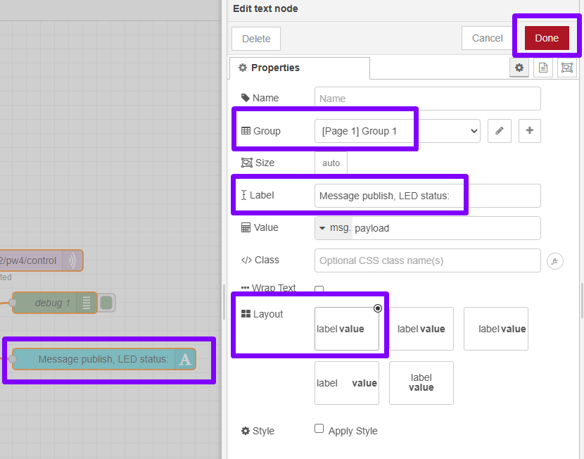

- Setup debug

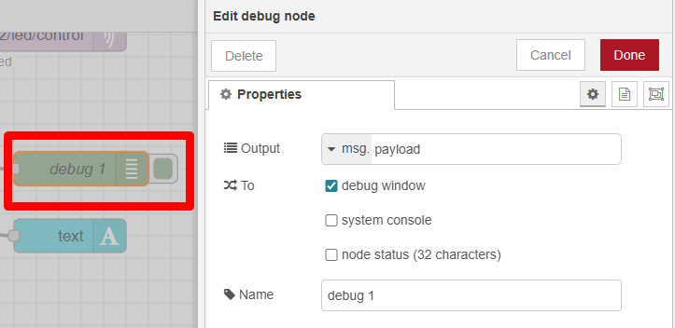

- Setup ui LED

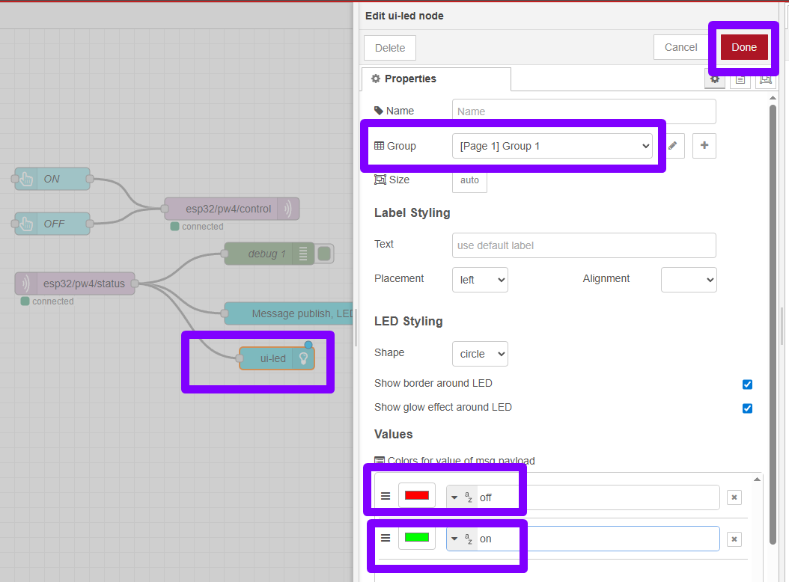

- After Setup is done,click deploy
- Open dashboard
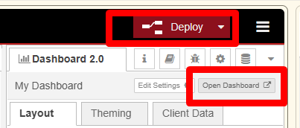

- The deployed dashboard in browser, is shown below.

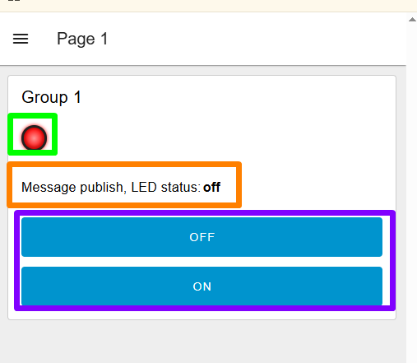

Setup codes in Arduino IDE
- Open Arduino IDE
- Copy code from this link : https://github.com/zulkeflipolimas/DEC30252-Student/blob/main/MQTT%20PreLab/mqtt_subscribe_publish.ino

- Modify the blank spot with suitable credential
  - Wifi SSID
  - Wifi Password
  - Broker Server (refer Node Red broker server link in MQTT OUT Nodes)
  - Subscribe Topic (refer Node Red topic in MQTT OUT Nodes)
  - Publish Topic (refer Node Red topic in MQTT IN Nodes)

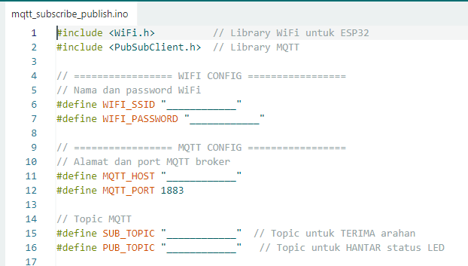

- Upload the code to the ESP32 board. Wait for the upload to finish.
- Open the Serial Monitor in Arduino IDE.
- Set baud rate to 115200.
- Observe the ESP32 connecting to WiFi and the connecting to MQTT server

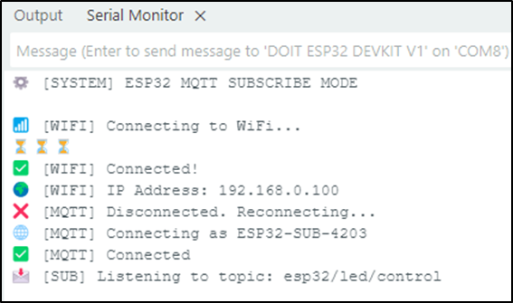

Receiving and Processing MQTT message
- Test the ON button on Node Red deployed dashboard
  - Observe the ESP32 LED, the LED should turn ON
  - Observe UI LED on dashboard browser LED1
  - Observe the Serial Monitor:
    - The received topic and message should be displayed.
    - The LED status should be indicated as ON.

- Test the OFF button on Node Red deployed dashboard
  - Observe the ESP32 LED, the LED should turn OFF.
  - Observe UI LED on dashboard browser LED1
  - Observe the Serial Monitor:
    - The received topic and message should be displayed.
    - The LED status should be indicated as OFF.

- Verify the message payload receive by open Debug Window
  - Make sure when button pressed, the payload on or off is appear on debug window as shown below
  - Debug window can help u tracing the flow of data, payload and message during your code is running.
  - Its include time and date when payload/message received

